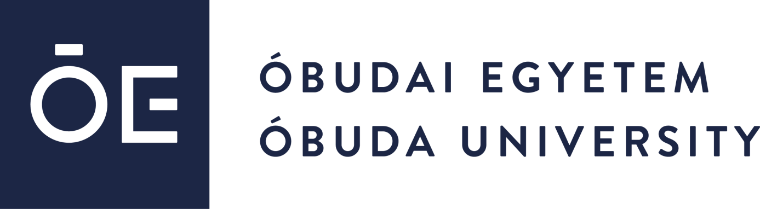

CALL FOR APPLICATION
for the title
„Consolidator Researcher”
by Óbuda University

Tender code: ÓE-RH-CONRES-2023

Óbuda University (hereinafter: University) announces an internal scholarship application for the title “Consolidator Researcher”.

- Introduction, aim of application call
The purpose of the University is to support those habilitated scientific researchers who are/will be in employment with the University, whose remarkable scientific research and innovation results and / or significant publishing activities justifying, in order to help the beneficiary to achieve the title of university professor.

- Amount of scholarship
  - Amount: 100 000 000 HUF/person/supported period.
  - Duration of support provided by the University: 48 months in case of a continuous employment.

- Eligible areas
Any application in any field of science may be submitted for this call.

- Eligibility for application
  - Applications for this call may be submitted by scientific researchers who provide outstanding performance and are/will be in full-time employment with the University and have a demonstrably high level of scientific research and innovation results and / or significant publications.
  - Conditions:
- at least 17 Hirsch Index and 700 citations (Google scholar);
- compliance with 60% of the doctoral requirements of the Hungarian Academy of Sciences;
- habilitation / or 70% of the doctoral requirements of the Hungarian Academy of Sciences.

- Grounds of exclusion
Applicants may not receive a scholarship in the following cases:
- credibly proved to have provided or made false, misleading or deceptive information which substantially affected the content of the grant decision when submitting the application,
- do not provide declarations and documents specified in the call for application or withdraw submitted declaration.

- Available budget, number of applicants for the scholarship
The total amount available for applications is HUF 300,000,000, of which the source is the budget of Óbuda University.
Number of persons eligible for support: 3.

- Supported period
The supported period is 48 months.

- Deadline for application
Applications must be submitted between 7 March-29 March 2023. Deadline for application: 29 March 2023.

- Submission, documents
Applications can only be submitted in electronic form, submitted to the Rector of Óbuda University (rektor@uni-obuda.hu), by uploading the following documents:
- English language CV – PDF format;
- scan of the PhD degree;
- habilitation document (if the applicant holds a habilitation);
- publication list, (in case of journals: impact factor and qualification of the journal (SCImago and Clarivate journal ranking) and H-index;
- research plan and preliminary financial plan for the four years of the supported period in max. 5 pages in A4 format, font size 12 in English.

- Assessment of the application
  - A formal and content evaluation takes place during the decision-making process. Based on the submitted applications, in the first round of the application procedure a decision will be made by 19 April 2023 of the participants qualified for the second round. The final decision will be made after an oral hearing of those who have reached the second round.
The start date of the project may be between 1 May - 1 July, 2023. There is no appeal against the decision in favour.
  - The professional manager and organizer of the application is the Committee requested by the Rector. The Rector will decide on the award of the title “Consolidator Researcher” and the use of the grant on the basis of a proposal from the Commission.

- Tasks undertaken by the supported applicant after receiving the grant
Supported applicant undertakes:
- at least three Q1(SJR) and Top 10% InCites publications (article, review) per year, of which at least in two the consolidator researcher is first or last author, with indication of Óbuda University affiliation;
- Óbuda University PhD thesis supervision, at least 1 PhD student obtains a degree during the grant period;
- meeting the requirements of the MTA doctor, application for MTA doctor by the end of the supported period;
- in case of not maintaining habilitation: obtain habilitation and application for MTA doctor by the end of the supported period;
- joining an existing research center of the EKIK and setting up a scientific research group
- “Lendület” application, submission of 2 Erasmus+ applications during the supported period and submission of the ERC Consolidator application in the 3rd year of this period;
- establishing international relations;
- Participation at IEEE HS conferences on a semi-annual basis;
- 2 special sessions during the granting period at flagship international conferences of the research topic;
- detailed work plan and financial plan at the beginning of each year;
- annual report on the results achieved.

- Use of the grant
The full amount of the scholarship can be used freely in compliance with the legal provisions in force with the proviso that no more than 20 % of the grant may be claimed as indirect costs by the applicant.

- Termination of the Fellowship
The right to use the title and the grant expires at the end of the supported period and before the end of the supported period, if the applicant's employment ends with the University.

